National University of Computer and Emerging Sciences

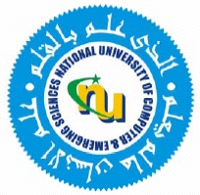

Laboratory Manual # 4
Programming Fundamentals Lab

Course Instructor | Ms. Arooj Khalil
Lab Instructor(s) | Ms. Kissa Tanvir  Mr. Zaeem yusuf
Section | BCS-1B
Semester | Fall 2023

Department of Computer Science
FAST-NU, Lahore, Pakistan

Objectives:
In this lab, students will practice:
- C++ code
- Input/output function
- Condition Operator

Questions:
Simple if and if else questions
Question would be written on board.

